**Title of the article**

**Scrum is better than CPM – a case study of a software project “HRM system with Biometric Attendance”.**

**Nguyen Dinh Nhat Minh**

**Student id 103802490**

**103802490@student.swin.edu.au**

# Abstract

This essay attempts to compare the effectiveness of Scrum, an agile software development approach versus a traditional approach to software project management, the Critical Path Method. The comparison will be achieved by applying scum or CPM to address challenges or enhance development management within a case study of a project named HRM system with biometric attendance. The effectiveness of the scrum methodology when it comes to the modern software development process outweighs that of the traditional Critical Path Method because the scrum agile methodology shines in terms of increasing adaptability, changes responsiveness, and collaboration between different parties.

# 1. Introduction

Building a software involves a lot of elements, from planning the scope to developing a product, these elements can contribute to making the cycle of software development complex as the duration of the project goes on and tasks start increasing. Hence, it is of the utmost importance that the project management bodies select and use the right Software Development Life Cycle models to devise a plan that would accommodate their project effectively [1, 2].

Within this essay, we will attempt to discuss how the scrum and CPM approach aid in addressing the challenge brought about by a software project, which is the case study that will be used as our analysis medium title: “Human Resource Management system with Biometric Attendance” or HRMwBA in lieu of a better acronym.

# 2. Background

## 2.1 Software Project "HRMwBA":

The project HRMwBA is a web-based application development project created to address the need for stream-lining human resources management within the Gemadept corporation. The application will consist of all the human resource management needs from payroll, employees information tracking, to timely visualised report on the employee’s progress.

This application will be further improved by adding a fingerprint scanner-based biometric attendance system. With the use of this technology, the HR department can precisely track when employees clock in, which makes it possible to calculate their actual work hours for a variety of purposes, including payroll and performance reviews. As a result, this is an improvement over conventional HRM systems, where regulation is lax, and attendance is frequently not formally documented.

The objectives set the stage for the team coming up with the features that would satisfy the requirement for this project:

* Employee Information Management.
* Recruitment and Applicant Tracking.
* Onboarding and Offboarding.
* Payroll Management.
* Time and Attendance Tracking.
* Reporting and Analytics.
* Performance Management.
* Learning and Development.
* Integration with Existing Systems.

These features are expected to be achieved in a period of 4 sprints each lasting around 4 weeks (21 days) and have around 5 to 6 products to be done. As of the time of this research, our team had successfully developed our first sprint and created a usable first version of the product.

## 2.2 Overview of Scrum:

A method that is based on the agile framework, scrum according to Schwaber and Beedle [3] is an empirical approach that reintroduces flexibility, adaptability and increased productivity into system development. The Scrum process cuts through complexity and focuses exclusively on building software that meets business needs.

Scrum breaks a project down into iterations of fixed duration (one to four weeks) called Sprints. And personnel can assume one of the three main roles.

* Product Owner: responsible for the product vision represented by a Product Backlog.
* The Scrum / Delivery team: a group of people that is in charge of developing the software.
* The Scrum Master: guides the team through the process and helps the team to resolve issues that may occur.

Scrum gained its effectiveness [4] since it promotes regular inspection and adaptation through a variety of activities like frequent meetings and check ups to make sure everyone stays on progress, and work from everyone can be synchronized better. Moreover at the end of each sprint, retrospective review or sprint demo that would be used as reports on progress of the project.

These elements combined well with one another and create a very realistic, effective and efficient model that is loved by every project manager in the world.

## 2.3 Overview of Critical Path Method (CPM):

The Critical Path Method, a traditional software development methodology used to determine the critical path in a project’s network, project duration, and efficient use of resources. CPM is used to plan and manage complex projects with interdependent activities as it follows a sequential approach, meaning that in order to achieve one product, the prior product must be done first.

In CPM, the project is represented as a network of activities [5], each with its duration and dependencies on other activities. The critical path in a CPM is meant to figure out the longest sequence of activities that determines the minimum duration of the project, which means that the duration of the project is fixed and changes within any activities will directly translate to the project’s overall duration. Management bodies can leverage CPM’s critical path analysis to identify critical activities and allocate resources accordingly to ensure the smooth delivery of the project.

Just like any traditional project management framework, CPM would perform especially well in projects that have well defined scope and detailed plan from the get-go, or within an environment of robust communication and strong commitment [6]. Which is one of the reasons why software developed with this method does not have any extra features but does carry a higher chance of delivering software to clients.

# 3. Discussion

**3.1 Main Challenges of the Software Project:**

Throughout the development of the HRMwBA project, several challenges emerged like (1) *Tight deadlines* as we originally devised each sprint in our project to be 4 weeks long, however, due to time constraint, we must shorten the time to 2 weeks, which made our time get more tight. (2) *Expanded scope* because we are determined to incorporate one of our later sprint’s into the first sprint midway through the project, which made our scope for sprint 1 expanded a little. (3) *Rushed development* due to time constraints, hence, we must rush our website’s development. (4) *Knowledge deficit* among team members**,** as our team members studied IT, hence, we have little knowledge when it comes to human resource management, which is why it took us quite some time to research and develop a plan that would suit HRM business needs.

**3.2 Scrum's Approach to Addressing Challenges:**

It is not surprising to learn that scrum helped us address almost all of our problems with our HRMwBA project. Because we designed our product based on scrum's product backlog, we can adjust the priority of the products at any time during the project. Which allows us to develop the product sooner than planned.

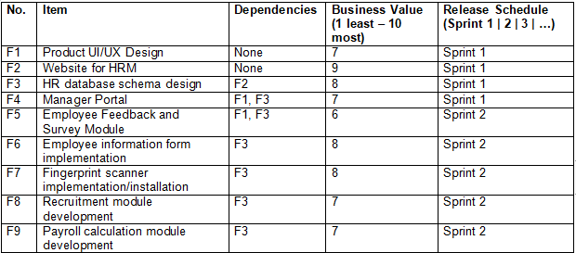

*Figure 3.2.1: Original Product Backlog*

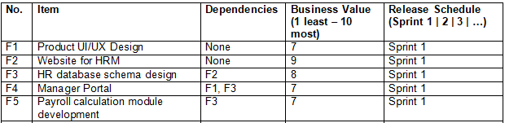

Figure 3.2.2: Adapted Product Backlog

We also apply scrum’s frequent meeting practice and conduct meetings twice to thrice a week to discuss what each member of the team is doing, and what news there to be had. This led to the team being able to adjust the time for each product as well as speed up the human resource research for all of us as we can exchange our findings to one another within those meetings.

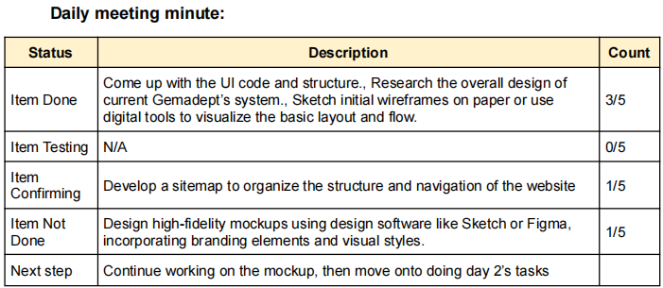

*Figure 3.2.3: Meeting minute summary example*

**3.3 CPM's Approach to Addressing Challenges:**

The CPM analysis did help us combat the rushed development drawback of our project. By creating a work breakdown structure (WBS) we were able to determine the most critical product that needed to be done, and it helped us know what task we need to be doing, how long it should take, these elements and make our development move more smoothly.

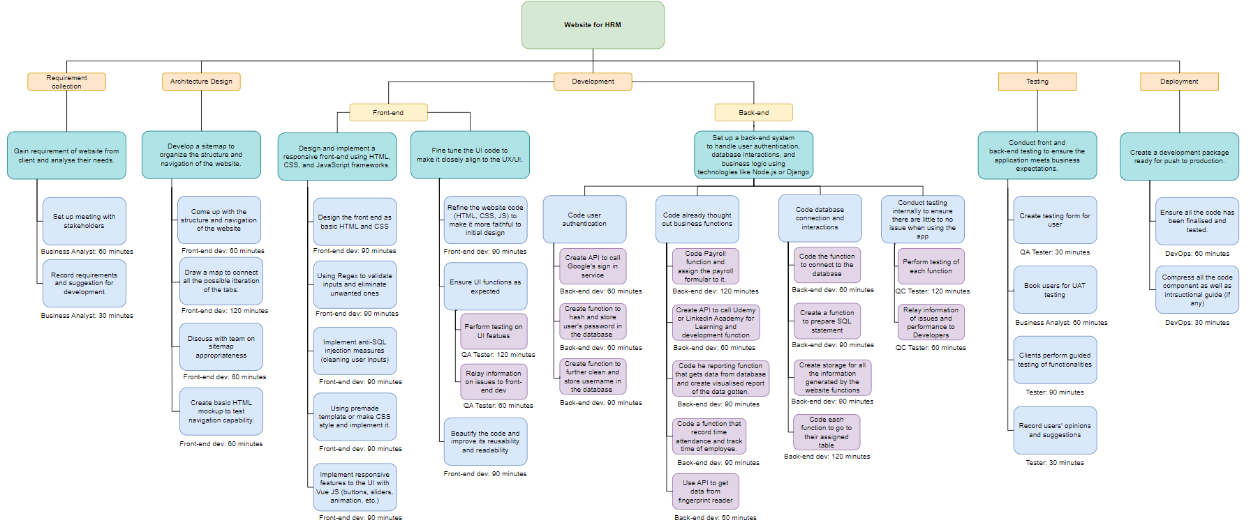

*Figure 3.3.1: WBS for one of the product*

Even though this style of project management can pull through when detailed objectives are made, should we pursue this approach from the get-go, we would not be able to develop our website how we envisioned it and will slow down development as we need to progress each product step-by-step. Despite this benefit, it can be easy to overestimate or underestimate the time it could take to carry out any product, which makes time planning of this approach unrealistic at times [7].

**3.4 Comparison and Conclusion:**

Within the HRMwBA project, Scrum's characteristics like adaptability, flexibility, and its practice of regular discussion did create more work for us to do and expanded our original scope a little. However, it made up for this by addressing most of our main challenges with those same characteristics. In addition, this method allows us to develop our sprint’s product however we like and does not need to rely on complex dependencies of other products.

Even though CPM’s approach was not useless as it helped us pull through our rushed schedule with its scheduling, it does not prove as significant as Scrum. It was only taken into account when doing initial planning for each product (which changes as the project goes on) and diving head first into creating an intricate network of tasks and dependencies will be too complex and cost too much precious time and resources for our team.

# 4. Conclusion

Through the case study of the Human Resource Management system with Biometric Attendance, it's evident that the Scrum methodology outperforms the CPM approach due to its ease of use and other characteristics. Scrum's adaptability and simplicity make it well-suited for the rapid development of software [8], especially in our project's context. In contrast, CPM's reliance on extensive planning and complex task networks does not align well with the dynamic nature of today's software development landscape and our project's specific needs.

# References

[1] R. S. Pressman, *Software Engineering: A Practitioner’s Approach*. McGraw-Hill Science, Engineering & Mathematics, 2010.

[2] R. K. Wysocki, *Effective Project Management : Traditional, Agile, Extreme.* Somerset: Wiley, 2011.

[3] K. Schwaber and M. Beedle, *Agile Software Development with Scrum*. Pearson, 2002.

[4] C. Scharff and R. Verma, “Scrum to support mobile application development projects in a just-in-time learning context,” *Proceedings of the 2010 ICSE Workshop on Cooperative and Human Aspects of Software Engineering - CHASE ’10*, 2010, doi: <https://doi.org/10.1145/1833310.1833315>.

[5] J. E. Kelley and M. R. Walker, “Critical-path planning and scheduling,” *Papers presented at the December 1-3, 1959, eastern joint IRE-AIEE-ACM computer conference on - IRE-AIEE-ACM ’59 (Eastern)*, 1959, doi: <https://doi.org/10.1145/1460299.1460318>.

[6] P. A. Hofmann, “Critical Path Method: An Important Tool for Coordinating Clinical Care,” *The Joint Commission Journal on Quality Improvement*, vol. 19, no. 7, pp. 235–246, Jul. 1993, doi: <https://doi.org/10.1016/s1070-3241(16)30004-9>.

[7] M. Lu and H. Li, “Resource-Activity Critical-Path Method for Construction Planning,” *Journal of Construction Engineering and Management*, vol. 129, no. 4, pp. 412–420, Aug. 2003, doi: <https://doi.org/10.1061/(asce)0733-9364(2003)129:4(412)>.

[8] P. Adi, “Scrum Method Implementation in a Software Development Project Management,” *International Journal of Advanced Computer Science and Applications*, vol. 6, no. 9, 2015.